10/11: Please see my comments in **Red** color.

A custom table would be built that would contain the following fields, at a minimum.

PO#

PO Internal ID

Vendor Name

Vendor Internal ID

Item

Item Internal ID

PO Line ID

Qty

Expected Receipt Date

Inbound Shipment #

Status

Can we create a **custom record type** as below? Please confirm.

*** Yes, as long as the table includes all the fields listed above. For PO Line ID, I thought this would be important, but maybe not. The custom table will be loaded with PO line items.

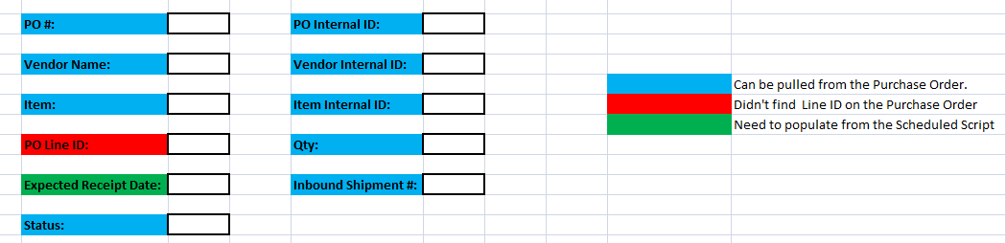

What if there are multiple line items for a single Purchase Order? Do we need to create an item sub list on the custom record type (or) there will be always one line item on the purchase order?

*** We will be loading PO line items into the custom table.

When a purchase order is created the line level information would be initially loaded into the custom table.

We can create an after submit user event script to populate the custom record type when the purchase order is created. Please provide the required fields list that need to be populated on the custom record type?

*** The required fields from the PO are PO#, PO Internal ID, Vendor Name, Vendor Internal ID, Item, Item Internal ID, PO Line ID (or whatever the unique identifier is for a PO Line), Qty, Expected Receipt Date (this will be updated by the Inbound Shipment Expected Receipt Date once the inbound shipment is created).

Once a PO line has been fully received it should be removed from the table.

A custom checkbox would be created on the Inbound Shipment line level.

We can create another Sub list field at the line level.

*** The checkbox would indicate whether that inbound shipment line has been added to the custom table.

A scheduled script would run to pull those new Inbound Shipment lines where the checkbox is FALSE and add them to the custom table, then mark that checkbox as TRUE on the inbound shipment line

We can write a script to pull the inbound shipments. Please provide the list of required fields that needs to be populated on the custom record type when we pull the inbound shipment lines.

*** Required fields would be Inbound Shipment number, Status, Expected Receipt Date.

A saved search could then be developed around the custom table that would allow you to pull both PO’s not assigned to Inbound Shipments and Inbound Shipments.

What are both PO’s? I didn’t understand this point. Could please elaborate?

*** I mean that PO’s and Inbound Shipments (both transactions) can be included on a saved search.

There would be a scheduled script that would cycle through the custom table with logic such as ‘if Inbound Shipment field is NULL get expected receipt date from PO Line else get expected receipt date from Inbound Shipment’.

We can create a script on custom record type to search through all the records where expected receipt date is NULL and populate it.

The expectation is when the Inbound Shipment detail is loaded into the custom table, it would be added to the previously created PO Line in the custom table.

Could you please elaborate it with an example test records?

Example:

PO123 is created for two lines. These would be loaded into the custom table as follows: